Topics to Cover
- data description and summarization
- frequency distributions
- relative frequency and cumulative frequency distributions
- histograms
- frequency distributions and histograms in Excel
- installing JMP

1. Data Description and Summarization

One major purpose of statistics is data description and summarization.

- Descriptive statistics vs. inferential statistics
- Sometimes also called 'data reduction'
- Facilitates communication, enhances clarity
- Focuses on the meaning of data
- Tables and Graphs/Charts/Figures
- 'A picture worth a thousand words'

Data
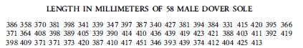

/Table
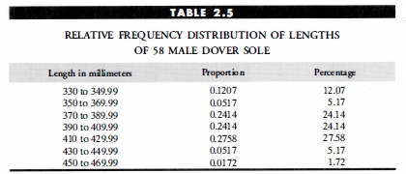

Graph
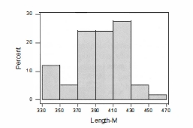

2. Frequency Distributions

The text's definition is incorrect.
A frequency distribution is a summary table in which the data are arranged
into conveniently established, numerically ordered class groupings or categories.

1. This is the definition of a frequency table.
2. Categories need not be numerically ordered.

Strict mathematical definition:
A frequency distribution is a mathematical function, f(x), that describes frequency with which a variable, x, takes every possible value.

Note: this formal definition includes continuous frequency distributions

But our working definition in this section is:
A frequency distribution (table) shows the number of times that a continuous or interval-level variable falls into each of a predetermined set of ranges.

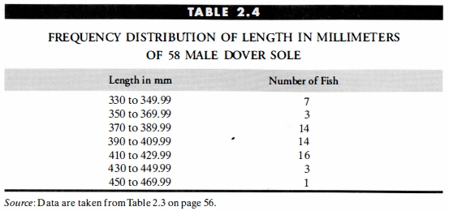

Designing a frequency table

- Number of categories/classes/ranges/intervals (usually 5 to 15)
- Avoid 0-frequency categories
- Choosing class intervals:

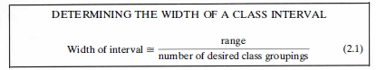

Example

- Range = (451 – 331) = 120
- Interval width = 120/6 = 20
- Text incorrect here? 7 or 6 intervals?
- Note: natural intervals more important than number of categories

3. Related Distributions

- Frequency distribution, f(x). The number of observations falling in each category, x. (x here is the categorized level, not the original variable)
- Relative frequency distribution, p(x). The proportion of observations in each category. p(x) = f(x)/N, where N is total no. of observations.%
- Percentage distribution, %(x). The percentage of observations in each category. %(x) = p(x) * 100
- Cumulative frequency distribution, c(x). For every category, the number of observations in that category or lower ones.
- Cumulative percentage distribution, For every category, the percentage of observations in that category or lower ones.

Summary Table: Frequency Distribution and Derived Distributions
Length in mm.  x | Frequency  f(x) | Relative Frequency  p(x) | Percent- age  % | Cumulative Frequency  c(x) | Cumulative Percentage  %
330 to <350 | 7 | 0.1207 | 12.07 | 7 | 12.07
350 to <370 | 3 | 0.0517 | 5.17 | 10 | 17.24
370 to <390 | 14 | 0.2414 | 24.14 | 24 | 41.38
390 to <410 | 14 | 0.2414 | 24.14 | 38 | 65.52
410 to <430 | 16 | 0.2759 | 27.59 | 54 | 93.10
430 to <450 | 3 | 0.0517 | 5.17 | 57 | 98.28
450 to <470 | 1 | 0.0172 | 1.72 | 58 | 100.00
Total | 58
Note: Dover sole (male) length in mm. Table 2.3 of Levine et al. (p. 56)

4. Histograms (Bar charts)

- Simple bar charts (vertical or horizontal)
- Convey same information as frequency table
- Different intervals produce slightly different results
- y-axis can be frequency, relative frequency, or percent

5. Frequency Distributions and Histograms in Excel

Two ways to make frequency table in Excel:

1. Frequency distribution using the Excel Data Analysis ToolPak (install)

File > Options > Add-ins

At bottom of page, select Excel Add-Ins from the Manage drop-down list (at the bottom) and click Go.

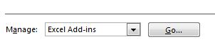

Select the Analysis ToolPak check box in the Add-Ins dialog box and then click OK.

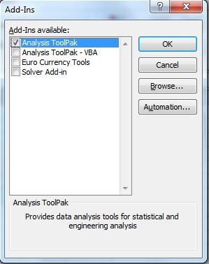

If an alert dialog box asking you if you want to install the add-in appears, click Yes.

Click Data tab in Excel menu and check far right to verify installation.

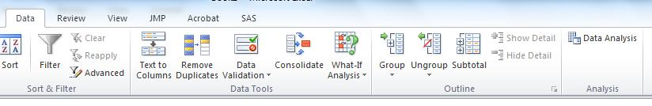

For more information:

http://office.microsoft.com/en-us/excel-help/present-your-data-in-a-histogram-HA010342785.aspx

2. Frequency distribution using the Excel Frequency function:

Explained here: http://support.microsoft.com/kb/100122

or here: http://www.youtube.com/watch?v=UASCe-3Y1to

Remember to use CONTROL+SHIFT+ENTER (in Microsoft Excel for Windows) or COMMAND+ENTER (in Microsoft Excel for the Macintosh) to enter the formula as an array.

Topic to be continued...

Homework
- Read pp. 44-45, 57-65.
- Install Excel Data-Analysis Add-in

